VIRGINIA TECH

Master of Public Health Program

Department of Population Health Sciences

College of Veterinary Medicine

Fall, 2017

Course Number: PHS 5044 /HNFE 5694 - Public Health Administration

Time and Location: Online

Instructor: Kerry J. Redican, MPH, Ph.D.

kredican@vt.edu

Office: 332 College of Veterinary Medicine

Phone/: 231-5743
Class Website: http://canvas.vt.edu

I .Course Description:

Today's health care and public health system is a complex and multi-faceted enterprise. Employees, regardless of their particular specialty, are often called upon to occupy administrative positions in various health organizations. Too often they must assume such responsibilities without experience in management or administration and without an understanding of the overall picture of the organization's environment and operations. This course will provide an overview of the major components which comprise or impact the health services organization. The topics presented will be considered from both a theoretical and practical viewpoint and will include: management, budgeting, organizational theory, health care management, planning, marketing, health law, and systems analysis. The machinery of policymaking and legal process that underpin the individual health care and public health systems, and then turns to an exploration of many of the fundamental problems and contemporary issues in health policy and law will be covered.

II. Purpose and Content: The purposes of this course are to (1) understand the evolution of health policy in the United States, (2) conduct a health policy analysis, and (3) address the major functions and issues surrounding supervisors of health service and public health institutions. The perspective is for those at all levels of health care management, as well as for those contemplating entrance into the field of health service administration.

III. Class Format: The course will be delivered in class, face to face with all class materials available at http://canvas.vt.edu

IV: Course Objectives

- Describe the legal and ethical bases for public health and health services (ASPH/CPH).

- Discuss the policy process for improving the health status of populations (ASPH/CPH).

- Apply the principles of program planning, development, budgeting, management and evaluation in organizational and community initiatives (ASPH/CPH).

- Apply principles of strategic planning and marketing to public health (ASPH/CPH).

- Apply quality and performance improvement concepts to address organizational performance issues (ASPH/CPH).

- Apply “systems thinking” for resolving organizational problems. (ASPH/CPH).

- Communicate health policy and management issues using appropriate channels and technologies (ASPH/CPH).

- Demonstrate leadership skills for building partnerships (ASPH/CPH).

V. Content Areas

I. Health Policy and Law
A. Policy and the Policy Making Process

B. Law and the Legal System
C. Understanding Health Insurance
D. Government Health Insurance Programs

E. Individual Rights in Health Care and Public Health

F. Health Care Quality Policy and Law

G. Structuring and Writing Health Policy Analysis

II. Management and Public Health Administration
A. The Nature of Management
B. Management as an Art and Science
C. Dichotomy of Management Tasks
D. Functions of a Manager
E. Management Process Benefits
F. Skills of a Manager
G. Modern Health Care Management Concerns

III. The Planning Process
A. Planning

B. The Decision-Making Process
C. Behavior and Decision Making

IV. Strategic Planning in Public Health
A. The Nature of Strategic Planning
B. Premises of a Strategic Plan
C. The Strategic Planning Process

V. The Organizing Process in Public Health
A. From Strategy to Structure
B. Classic Organization Theory
C. Modern Organization Theory
D. Organizing for Effectiveness

VI. Job Design
A. The Nature of Work
B. Role Ambiguity and Effectiveness
C. Job Stress and Burnout

VII. Effective Communication in Public Health
A. The Nature and Purpose of Communication
B. Communication Patterns
C. Achieving Effective Communication

VIII. Motivation in Public Health Management
A. What is Motivation?
B. Motivational Theories

C. Application of Motivational Theories

IX. Leadership Effectiveness in Public Health Management
A. Nature of Leadership
B. Theories of Leadership

C. Application of Leadership Theories

X. Appraising Performance and Dealing with Change
A. Performance Appraisal
B. The Change Process
C. Introducing and Managing Change

XI. Management Information Systems
A. Management Information Systems in Operation

XII. Health Care and Public Health Marketing
A. What is Marketing?
B. Marketing to Whom?
C. Health Marketing in Action

XIII. Medical/Legal Issues in Public Health and Health Care Administration
A. Confidentiality
B. Informed Consent
C. Risk Management
D. Affirmative Action

VI. Textbooks:



FORMAT: eBook
Pages: 220
ISBN: 978-1-284-00625-4
Price: $25.40

To Purchase the PUBLISH eBook “Public Health Administration”:

1.) Go to http://www.jblearning.com/catalog/9781284006254/ or go to www.jblearning.com and enter 9781284006254 into the “Search” bar.
2.) Click on the “Add to Cart” button.
3.) Proceed to “Checkout”.
4.) When prompted, create a JBLearning account or, if a returning user, log in.
5.) Complete the “Checkout” process. When finished, an automated message with an access code will be emailed to the purchaser.

To redeem a PUBLISH eBook Access Code go to http://publish.jblearning.com/ebooks. The redeemer will need to create a PUBLISH Account to complete the process.

The device requirements for viewing the eBook are on the catalog page. If there are any technical issues or questions, please contact the Jones and Bartlett Learning Tech Support team at www.jblearning.com/techsupport or by calling 800-832-0034, option “5”

Tentative Schedule*
*Note: Since the textbook is a custom book Chapters 1-12 are referred to as Burke and 13-15 Teitelbaum – these are the authors of the texts the chapters are from.

Date | Topic | Due | Readings
Lesson 1 | Introduction  Overview of Public Health Administration |  | Chapter 13 (Teitelbaum)
Lesson 2 | Public Health and the Bill of Rights | Constitution, Bill of Rights, Supreme Court Decisions Paper | Chapter 14 (Teitelbaum)
Lesson 3 | Health Law and the Legal System |  | Chapter 14 (Teitelbaum)
Lesson 4 | Health Policy and the Policy Making Process | Health Policy Questions Due | Chapter 15 (Teitelbaum)
Lesson 5 | Implementing Policy | Health Policy Analysis Paper | Chapters 1 and 2 (Burke)
Lesson 6 | Management: Planning |  | Chapter 4 (Burke)
Lesson 7 | Management: Organization |  | Chapter 4 (Burke)
Lesson 8 | Management: Directing and Communication |  | Chapter 9 (Burke)
Lesson 9 | Management: Leadership | Case Study 1 | Chapters 3 and 9 (Burke)
Lesson 10 | Management: Controlling |  | Chapters 6 and 8 (Burke)
Lesson 11 | Management: Human Resources | Case Study 2 | Chapter 4 (Burke)
Lesson 12 | Public Health Ethics |  | Chapter 5 (Burke)
Lesson 13 | Practice Issues in Public Health Administration: | (1) Case Study 3  (2) Ethics Cases | Chapter 7 (Burke)
Lesson 14 | Practice Issues in Public Health Administration: Diverse Workplaces | Final Exam | Chapter 10 and 12 (Burke)
Lesson 15 |  | Term Paper Due | Chapter 12 (Burke)

VII. Course Requirements

A general description of the requirements appears below. More specifics will be presented in class.

- Constitution, Bill of Rights, Supreme Court Decisions Paper: In 2-3 pages (double space, 12 pt font) (1) Identify and briefly describe what you think are the 6 big ideas in the U.S. Constitution; (2) the relationship between the Bill of Rights and public health; and (3) what you feel are the two most important supreme court decisions and why – (10%)

- Health Policy Questions: Short answers to question from Teitelbaum Chapters 13, 14 and 15 (5%).

- Case Studies: 3 Case Studies will be analyzed throughout the semester. Each case study will focus on a management concept(s) covered in powerpoints/readings. Answer the questions associated with the case (30%).

- Health Policy Analysis: Application of a policy analysis framework to a public heath issue (10%)

Chose a public health, including health care related issue and
develop a short 3-5 page policy analysis that includes a problem statement, background, landscape, options, and
recommendations (See Checklist* Below).

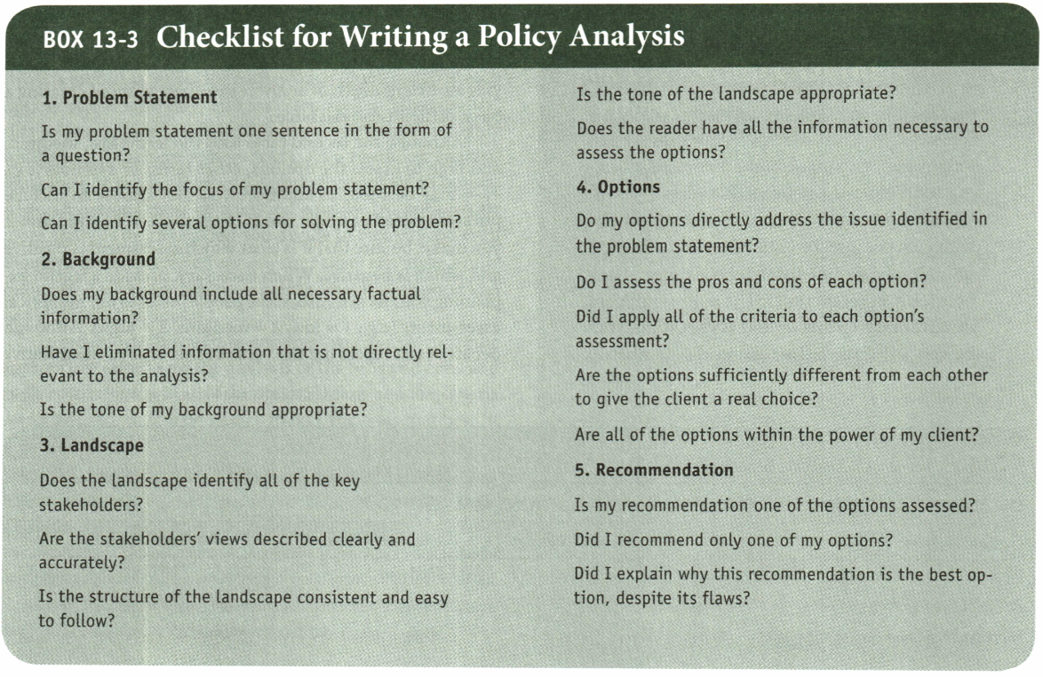

*From: Teitelbaum, JB and Wilensky, SE (2007), Essentials of Health Policy and Law, Jones and Bartlett.

(5) Final Exam: Comprehensive multiple choice exam (15%)

(6) Ethics Case Studies: Choose two of the ethics cases from the Ethics Case Studies pdf and answer the question at the end of the case study. Submit the answers in a Word document into you DropBox (5%)

(7) Term Paper: Application of course concepts to a fictitious health department (15%)

You have just been hired to plan a Regional Health Department in Virginia. To that end you will be responsible for designing all facets of the health department. Complete the following:

- Develop a mission statement for your health department.
- Develop three goals for the department and for each goal develop two objectives.
- Develop an organization chart for your health department to include the 6 major areas of public health.
- Choose one department from the organization chart and:
- Develop a job description for recruiting for the head of the department;
- Develop a human resource plan for departmental hiring;
- Develop a budget for the department

Value of Assignments

Constitution, Bill of Rights, Supreme Court Decision Paper: (10%)

Health Policy Questions: (10%)

Health Policy Analysis: 10%

Case Study 1: 10%

Case Study # 2: 10%

Case Study 3: 10%

Ethics Case Studies: 10%,

Final Exam: 15%,

Term Project: 15%,

Grading

Scale

100 – 94 = A

93 – 90 = A-

89 - 87 = B+

86 - 84 = B

83 - 80 = B-

79 - 77 = C+

76 - 74 = C

73 - 70 = C-

Honor System

All students are bound to the VPI & SU Honor System, which is outlined in the current University Policies for Student Life manual and in the Graduate Honor System Constitution, a copy of which may be found at http://ghs.grads.vt.edu/ghs_constitution.html. Students should review, in particular, the section on plagiarism, which includes “the copying of the language, structure, idea, and/or thoughts of another and claiming or attempting to imply that it is one's own original work. It also includes the omitting of quotation marks when references are copied directly, improper paraphrasing (see Plagiarism), or inadequate referencing of sources. Sources used in preparing assignments for classes, theses, dissertations, manuscripts for publication, and other academic work should be documented in the text and in a reference list, or as directed by the instructor or professor. Sources requiring referencing include, but are not limited to, information received from other persons that would not normally be considered common knowledge (Plagiarism), computer programs designed or written by another person, experimental data collected by someone else, graded permanently-returned materials such as term papers or other out-of-class assignments (koofers), as well as published sources”

Principles of Community:

Virginia Tech values respect, diversity and dignity of every person. Please read the Virginia Tech Principles of Community available at:

http://www.vt.edu/diversity/principles-of-community.html

Accommodations: If any student needs accommodations please contact me as soon as possible.

If you want more information about services available for students with disabilities, click here or visit the directly at: http://www.ssd.vt.edu/

If you have any questions about accommodations, please visit the description of accommodations available at:

http://www.ssd.vt.edu/accommodationdescriptions.htm

