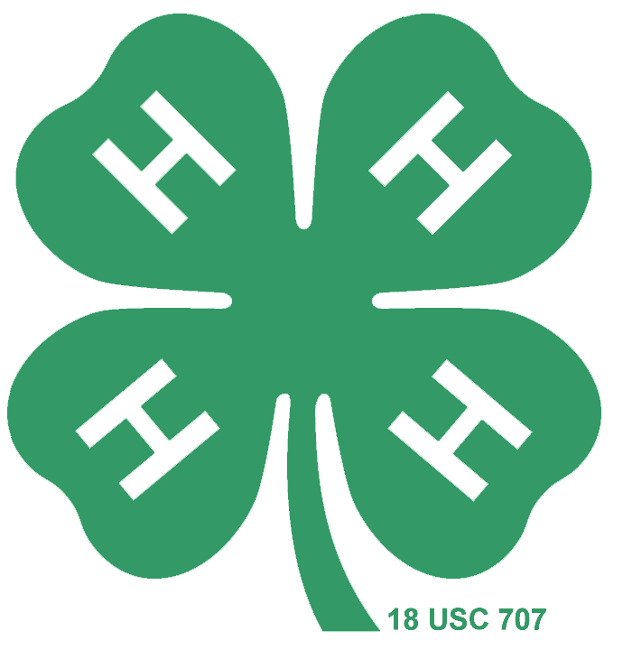


2023 4-H Essay Contest Announcement and Rules
Sponsored by The Foundation for the Preservation of Honey Bees, Inc.
& Virginia 4-H

Awards: Cash Prizes to 3 Top State Winners at these levels – 1st-$100
2nd- $50
3rd- $25
State winner will be forwarded on to National competition and could win cash prizes as follows:
1st - $750
2nd- $500
3rd- $250
Each state winner, including the national winners, receives an appropriate book about honey bees, beekeeping, or honey.

2023 Essay Topic:
The Importance of Beeswax
Although honey bees are much-beloved for honey, bees also produce beeswax that can be used in many ways. For this essay, a 4-H student should discuss why beeswax is so important to the hive (it's a pantry, it's a nursery, it's the dance floor), but also discuss their favorite way to use beeswax outside the hive. Photos of candles, soaps, or lip balms that are made to show the 4-H'er's skill in using beeswax are welcomed as are recipes or brief instructions.

Put on your thinking caps and GO!
An essential judging criterion is the scope of research you put forth in developing the ideas behind your essay—accounting for 40% of your score. The number of sources consulted, the authority of the sources and the variety of the sources are all evaluated. Personal interviews with beekeepers and others familiar with the subject are valued sources of information and should be documented. Note that “honey bee” is properly spelled as two words, even though many otherwise authoritative references spell it as one word.

-Rules on reverse/next page

Rules & Requirements:

- Contest is open to active 4-H Club members only. 4-H’ers who have previously placed first, second or third at the national level are not eligible; other state winners are eligible to re-enter.
- Requirements (failure to meet any one requirement disqualifies the essay) –
- Preparation for National Judging: ELECTRONIC SUBMISSIONS ONLY, double spaced, 12-pt. Times or similar type style, following standard manuscript format. Submit as a Microsoft Word compatible document.
- Write on the designated subject only.
- All factual statements must be referenced with bibliographical-style endnotes.
- A brief biographical sketch of the essayist, including date of birth, gender, complete mailing address, and telephone number, must accompany the essay.
- Length – the essay proper: 750-1000 words.
- The word count does not include the endnotes, the bibliography or references, nor the essayist’s biographical sketch – which should be on a separate page.
- Essays will be judged on (a) scope of research – 40%; (b) accuracy – 30%; (c) creativity – 10%; (d) conciseness – 10%; and (e) logical development of the topic – 10%.
- Essayists should forward essays to the state judging team postmarked by April 14, 2023. The winner of the state contest will be forwarded to the national competition before May 1.
- The state winner will be announced on May 1, 2023 and the National Winner will be announced the week of June 15, 2023.
- All National entries become the property of the Foundation and may be published or used as it sees fit. No essay will be returned. The National winners’ essay will appear in an issue of the American Beekeeping Federation’s Newsletter.

- Email state entries by the deadline (April 14, 2023) to:
safishe3@vt.edu
In the subject line: VA. 4-H Beekeeping Essay Contest
All entries received will be promptly acknowledged; if you have not received an acknowledgment after 3 business days, please resubmit.

THANK YOU FOR YOUR SUPPORT OF THIS PROGRAM

